**Task 3: Prescriptive solution**

The solution approach is to determine the demand price elasticity in the SFO area. According to this elasticity, we can suggest a price modification to lower or increase demand according to business needs. Last but not least, the ultimate objective should be to maximize revenue (in most cases) and this will be discussed by the end of this memo.

**Demand price elasticity model**

We will use a linear regression model to determine the coefficients of the price variable in the linear model. The first experiment has as a dependent variable the quantity of trips started per hour as a representation of the demand. The second experiment set the dependent variable as the sum of minutes demanded by hour. The price variable was set as the median price per minute cost of the trip. Both variables were log transformed to represent the relative percentual variation and not absolute impact.

In both experiments the other control variables used were: Weekend, 7_to_12hs and lead_time_median. The last was not used in the second experiment as it was not statistically significant.

Both models gave a good fit. And the sign and values of the coefficients are similar which is good. The linear regression details are in the jupyter notebook **task3.ipynb** so i will focus on the solution:

* Demand elasticity (qty of trips) on CPM: -2.5855
* Demand elasticity (minutes demanded) on CPM: -3.4324

**Price impact**

The solution would be to modify the price proposed by the base model / set of rules so the capacity of the fleet would be used up to a certain threshold previously specified.

We will set the target capacity at 90% and cap the price variation at no more than 15% variation, both over and under. This means that a certain zip code has 120 minutes capacity per hour (two cars with no interruptions) and 50 minutes are being used historically, target capacity is set at 108. Price impact required to reach 108 would be -62.92% with a coefficient of 3.4324.But as the price cap is at 15%, we would only modify prices by -15% instead.

According to the exploratory data analysis, most zip codes during the whole days tend to have free capacity, exceptions aside.

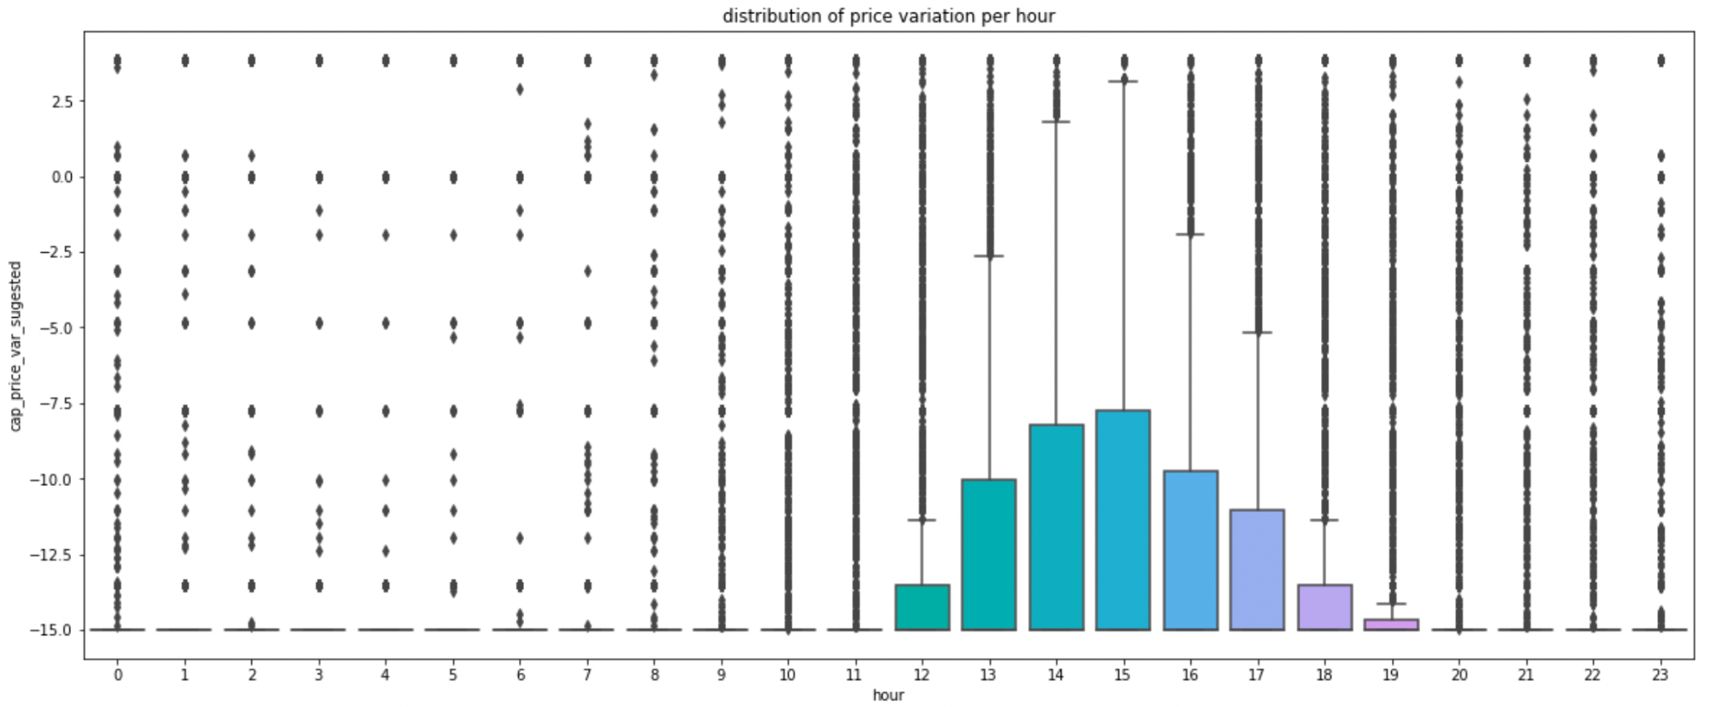

Price variation suggested during dawn is mostly at -15% because there is (except outliers) capacity available. Between 12hs and 18hs, as the remaining capacity is lower because of higher demand, 50% of the price suggestions are between -15% and -10% and not always at -15% like the other hours.

This plot shows the hypothetical impact on the demand by this solution, **BEFORE** (left) price variation and **AFTER** (right) prescriptive solution is applied.

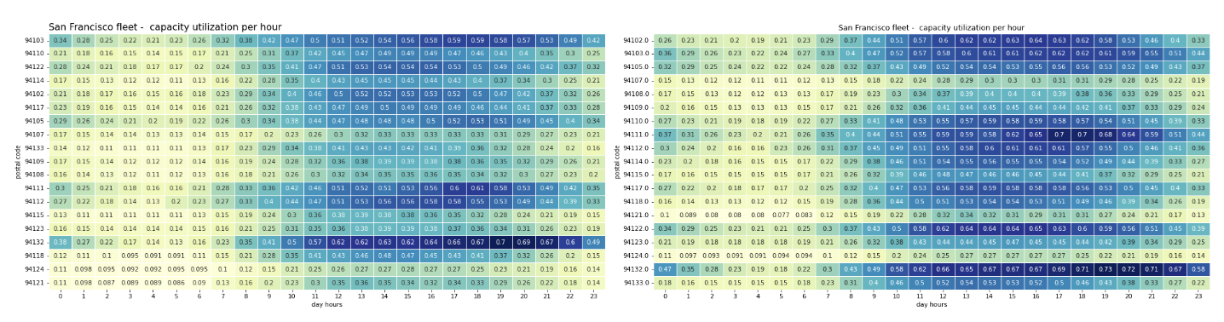

**Conclusion and next steps**

This solution if fairly simple but clear enough as a first experiment. And to be proven effective the recommendation would be to test it randomly on multiple zip codes on multiple times and validate the impact of prices on demand with a traditional AB Testing. Further work could mix more business insights and restrictions to further increase the positive impact. We are working with censored data, as we don't know when a person sees the price but doesnt rent. Including information about how many users see the price tag and leaves the platform would improve the solution. Weather data, segment of customers (demographics, past consumption), car type would also give better insights for a more robust solution.

Most importantly, the main objective usually is to improve rentability by dollars invested. This means that considering costs, maintenance of the fleet (demands time) and other basic aspects of the service is required to build a better solution. Target demand and price should be dependant variables of rentability. This could be part of an optimization solution where resources should be allocated where the demand pays better and is more stable (linear optimization solutions). Cars could be relocated at different zip codes week by week depending on future demand segments that were predicted by secondary models.